From: <https://digitalcommons.unl.edu/cgi/viewcontent.cgi?article=1496&context=icwdm_usdanwrc>

Species groups of birds reported as struck by civil aircraft in the United States at heights 0-500 (152 m), 501–3,500 (153–1,067 m), and 3,500-100,000 feet above ground level (AGL), 1990–2004.

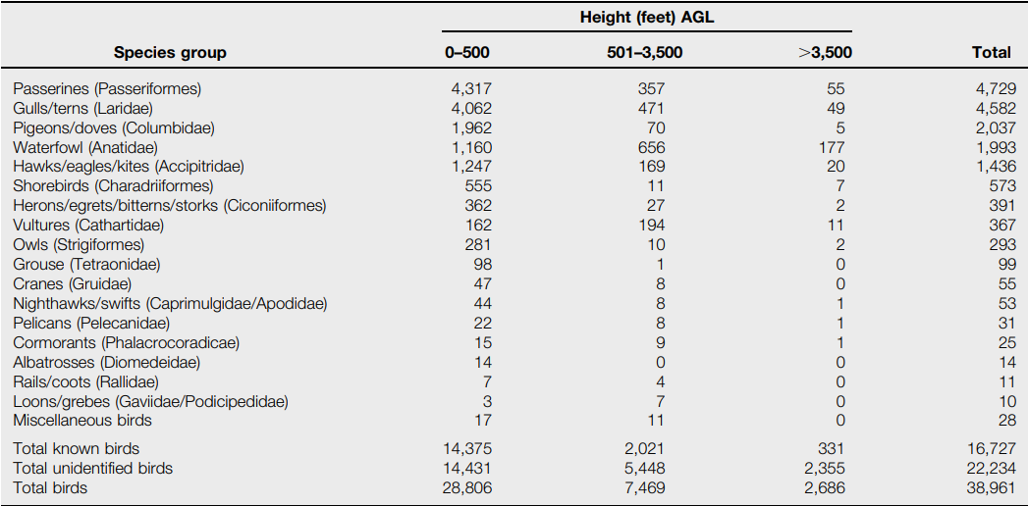

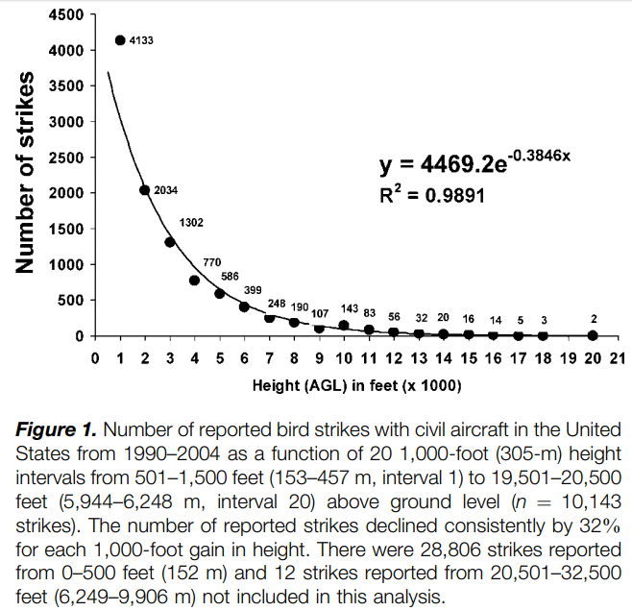

**Proportion of Strikes by Day and Night**

Overall, there were about 2.5 times more strikes reported during daylight hours than at night. However, because an estimated 4.5 times more aircraft movements occurred during day than at night, about 1.8 times more strikes per aircraft movement occurred at night than in the day. This overall higher strike rate at night was due to the pronounced proportion of strikes above 500 feet occurring at night. About 61% of the reported strikes above 500 feet occurred at night compared to 18% of aircraft movements. In contrast, proportionally fewer strikes occurred at more than 500 feet at night (16%), compared to the 18% of aircraft movements at night. Above 500 feet, about 7 times more strikes occurred per aircraft movement at night compared to day.

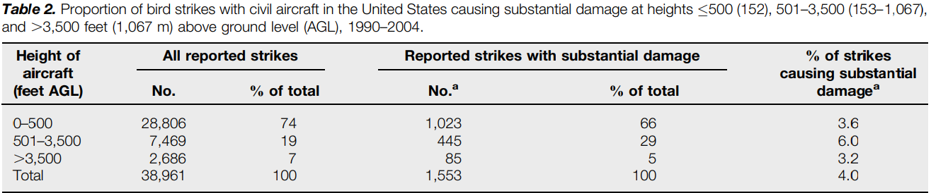

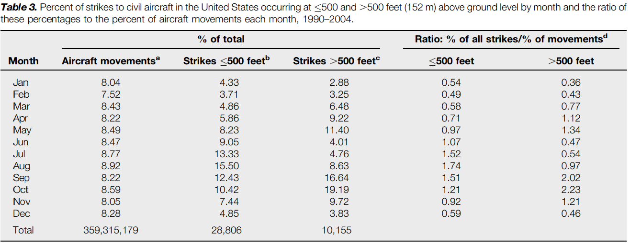

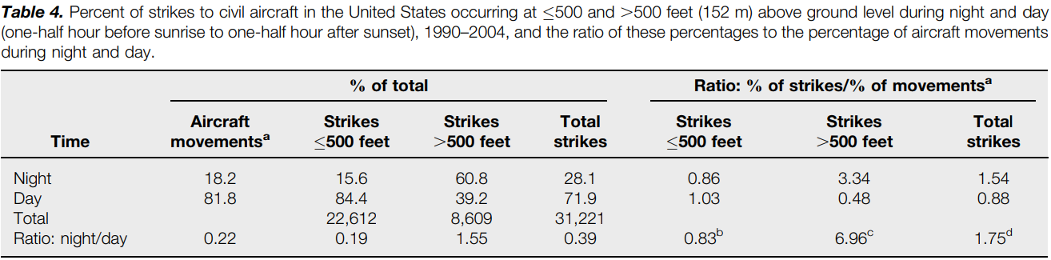

**Management Implications**

Management programs to reduce bird strikes with civil aircraft should focus on the airport environment because 66% of strikes causing substantial damage to aircraft occurred at 500 feet. Daylight hours during the months of July–October, especially August, had the highest strike rates below 500 feet. Outside the airport environment, the height zone from 500 feet to 3,500 feet is the most hazardous, especially at night. Because strikes decline exponentially by 32% per 1,000-foot increase in height above 500 feet, military planners can substantially reduce the mean probability of bird strikes by increasing the height of training flights. A 2,000-foot increase in height (e.g., from 1,500 feet to 3,500 feet) translates to a 54% reduction in the mean probability of a strike. Pilots of civil transport aircraft should minimize flight time and airspeed during climb and descent flight phases below 10,000 feet and especially below 3,500 feet at night during periods of migration to reduce the probability and severity of strikes.

Some interesting conversations: <https://www.quora.com/How-many-airplanes-fly-each-day-in-the-world>

From: <https://en.wikipedia.org/wiki/Bird_strike>

The [Federal Aviation Administration](https://en.wikipedia.org/wiki/Federal_Aviation_Administration) (FAA) estimates bird strikes cost US aviation 400 million [dollars](https://en.wikipedia.org/wiki/United_States_dollar) annually and have resulted in over 200 worldwide deaths since 1988.[[54]](https://en.wikipedia.org/wiki/Bird_strike#cite_note-BSC-USA2-54) In the United Kingdom, the Central Science Laboratory estimates[[7]](https://en.wikipedia.org/wiki/Bird_strike#cite_note-allan-7) that worldwide, the cost of birdstrikes to airlines is around US$1.2 billion annually. This cost includes direct repair cost and lost revenue opportunities while the damaged aircraft is out of service. Estimating that 80% of bird strikes are unreported, there were 4,300 bird strikes listed by the [United States Air Force](https://en.wikipedia.org/wiki/United_States_Air_Force) and 5,900 by US civil aircraft in 2003.

Most bird strikes involve large birds with big populations, particularly [geese](https://en.wikipedia.org/wiki/Geese) and [gulls](https://en.wikipedia.org/wiki/Gull) in the United States. In parts of the US, [Canada geese](https://en.wikipedia.org/wiki/Canada_geese) and migratory [snow geese](https://en.wikipedia.org/wiki/Snow_geese) populations have risen significantly[[17]](https://en.wikipedia.org/wiki/Bird_strike#cite_note-BSC-USA-17) while feral Canada geese and [greylag geese](https://en.wikipedia.org/wiki/Greylag_geese" \o "Greylag geese) have increased in parts of Europe, increasing the risk of these large birds to aircraft.[[18]](https://en.wikipedia.org/wiki/Bird_strike#cite_note-18) In other parts of the world, large birds of prey such as [*Gyps*](https://en.wikipedia.org/wiki/Gyps) vultures and [*Milvus*](https://en.wikipedia.org/wiki/Milvus) kites are often involved.[[5]](https://en.wikipedia.org/wiki/Bird_strike#cite_note-thorpe-5) In the US, reported strikes are mainly from [waterfowl](https://en.wikipedia.org/wiki/Wildfowl) (30%), [gulls](https://en.wikipedia.org/wiki/Gull) (22%), [raptors](https://en.wikipedia.org/wiki/Bird_of_prey) (20%), and [pigeons and doves](https://en.wikipedia.org/wiki/Columbidae) (7%).[[17]](https://en.wikipedia.org/wiki/Bird_strike#cite_note-BSC-USA-17) The Smithsonian Institution's Feather Identification Laboratory has identified [turkey vultures](https://en.wikipedia.org/wiki/Turkey_vultures) as the most damaging birds, followed by Canada geese and [white pelicans](https://en.wikipedia.org/wiki/American_white_pelican),[[19]](https://en.wikipedia.org/wiki/Bird_strike#cite_note-wired-19) all of which are very large birds. In terms of frequency, the laboratory most commonly finds [mourning doves](https://en.wikipedia.org/wiki/Mourning_dove) and [horned larks](https://en.wikipedia.org/wiki/Shore_lark) involved in the strike.[[19]](https://en.wikipedia.org/wiki/Bird_strike#cite_note-wired-19)

The largest numbers of strikes happen during the spring and fall migrations. Bird strikes above 500 feet (150 m) altitude are about 7 times more common at night than during the day during the bird migration season.[[20]](https://en.wikipedia.org/wiki/Bird_strike#cite_note-20)

Large land animals, such as deer, can also be a problem to aircraft during takeoff and landing. Between 1990 and 2013, civil aircraft experienced more than 1,000 collisions with deer and 440 with [coyotes](https://en.wikipedia.org/wiki/Coyote).[[17]](https://en.wikipedia.org/wiki/Bird_strike#cite_note-BSC-USA-17)

An animal hazard reported from [London Stansted Airport](https://en.wikipedia.org/wiki/London_Stansted_Airport) in England is [rabbits](https://en.wikipedia.org/wiki/Rabbit): they get run over by ground vehicles and planes, and they pass large amounts of droppings, which attract mice, which attract [owls](https://en.wikipedia.org/wiki/Owl), which become another birdstrike hazard.[[21]](https://en.wikipedia.org/wiki/Bird_strike#cite_note-21)

Interesting facts:

The first reported bird strike was by [Orville Wright](https://en.wikipedia.org/wiki/Wright_brothers) in 1905. According to the Wright Brothers' diaries, "Orville … flew 4,751 meters in 4 minutes 45 seconds, four complete circles. Twice passed over fence into Beard's cornfield. Chased flock of birds for two rounds and killed one which fell on top of the upper surface and after a time fell off when swinging a sharp curve."[[5]](https://en.wikipedia.org/wiki/Bird_strike#cite_note-thorpe-5)

During the [1911 Paris to Madrid air race](https://en.wikipedia.org/wiki/1911_Paris_to_Madrid_air_race), French pilot [Eugene Gilbert](https://en.wikipedia.org/wiki/Eugene_Gilbert) encountered an angry mother eagle over the [Pyrenees](https://en.wikipedia.org/wiki/Pyrenees). Gilbert, flying an open-cockpit [Bleriot XI](https://en.wikipedia.org/wiki/Bleriot_XI), was able to ward off the large bird by firing pistol shots at it but did not kill it.[[55]](https://en.wikipedia.org/wiki/Bird_strike#cite_note-55)[[56]](https://en.wikipedia.org/wiki/Bird_strike#cite_note-domenica-56)

The first recorded bird strike fatality was reported in 1912 when aero-pioneer [Cal Rodgers](https://en.wikipedia.org/wiki/Cal_Rodgers) collided with a gull which became jammed in his aircraft control cables. He crashed at [Long Beach, California](https://en.wikipedia.org/wiki/Long_Beach,_California), was pinned under the wreckage, and drowned.[[3]](https://en.wikipedia.org/wiki/Bird_strike#cite_note-sodhi-3)[[57]](https://en.wikipedia.org/wiki/Bird_strike#cite_note-57)

The greatest loss of life directly linked to a bird strike was on October 4, 1960, when a [Lockheed L-188 Electra](https://en.wikipedia.org/wiki/Lockheed_L-188_Electra), flying from Boston as [Eastern Air Lines Flight 375](https://en.wikipedia.org/wiki/Eastern_Air_Lines_Flight_375), flew through a flock of [common starlings](https://en.wikipedia.org/wiki/Common_starling) during take-off, damaging all four engines. The aircraft crashed into [Boston](https://en.wikipedia.org/wiki/Boston) harbor shortly after takeoff, with 62 fatalities out of 72 passengers.[[58]](https://en.wikipedia.org/wiki/Bird_strike#cite_note-Telegraph-58) Subsequently, minimum bird ingestion standards for jet engines were developed by the FAA.

From: <http://airportlifestyle.com/bird-strikes/>

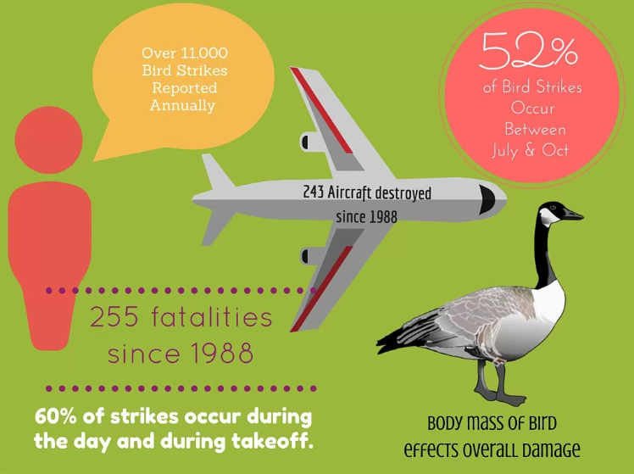

Something interesting could be gotten from here: <https://aviation.stackexchange.com/questions/23420/how-many-bird-strikes-are-there-per-year-any-world-wide-statistics>